EXPERIMENT-11:
Aim: To develop an online real estate platform that enables users to search, view, and book properties based on location, budget, and amenities while providing property management features for agents and administrators.
Code:
<!DOCTYPE html>
<html lang="en">
<head>
<meta charset="UTF-8">
<meta name="viewport" content="width=device-width, initial-scale=1.0">
<title>Home Finder</title>

<link href="https://cdn.jsdelivr.net/npm/bootstrap@5.3.3/dist/css/bootstrap.min.css" rel="stylesheet">

<style>
body{
background:#f4f6f9;
font-family:Arial,sans-serif;
}
.hero{
background:linear-gradient(to right,#0d6efd,#20c997);
color:white;
text-align:center;
padding:80px 20px;
}
.section{
display:none;
padding:20px;
}
.active{
display:block;
}
.card{
margin-bottom:20px;
}
.card img{
height:220px;
object-fit:cover;
}
.footer{
background:#212529;
color:white;
text-align:center;
padding:15px;
margin-top:20px;
}
</style>
</head>

<body>

<nav class="navbar navbar-expand-lg navbar-dark bg-dark">
<div class="container">
<a class="navbar-brand" href="#">Home Finder</a>

<div>
<button class="btn btn-outline-light btn-sm m-1" onclick="showSection('home')">Home</button>
<button class="btn btn-outline-light btn-sm m-1" onclick="showSection('properties')">Properties</button>
<button class="btn btn-outline-light btn-sm m-1" onclick="showSection('search')">Search</button>
<button class="btn btn-outline-light btn-sm m-1" onclick="showSection('login')">Login</button>
<button class="btn btn-warning btn-sm m-1" onclick="showSection('admin')">Admin</button>
</div>

</div>
</nav>

<!-- Home -->
<div id="home" class="section active">
<div class="hero">
<h1>Find Your Dream Home</h1>
<p>Search Houses, Apartments and Commercial Properties</p>
<button class="btn btn-light" onclick="showSection('properties')">
Browse Properties
</button>
</div>
</div>

<!-- Search -->
<div id="search" class="section container">

<h2>Property Search</h2>

<input type="text" class="form-control mb-3" placeholder="Location">

<select class="form-control mb-3">
<option>Select Property Type</option>
<option>House</option>
<option>Apartment</option>
<option>Commercial</option>
<option>Land</option>
</select>

<select class="form-control mb-3">
<option>Budget Range</option>
<option>₹10L - ₹20L</option>
<option>₹20L - ₹50L</option>
<option>₹50L+</option>
</select>

<button class="btn btn-success">
Search Property
</button>

</div>

<!-- Properties -->
<div id="properties" class="section container">

<h2>Available Properties</h2>

<div class="row">

<div class="col-md-4">
<div class="card">
<img src="https://images.unsplash.com/photo-1568605114967-8130f3a36994" class="card-img-top">
<div class="card-body">
<h5>Luxury Villa</h5>
<p>Location: Hyderabad</p>
<p>Price: ₹75 Lakhs</p>
<button class="btn btn-primary" onclick="bookProperty('Luxury Villa')">
Book Visit
</button>
</div>
</div>
</div>

<div class="col-md-4">
<div class="card">
<img src="https://images.unsplash.com/photo-1512917774080-9991f1c4c750" class="card-img-top">
<div class="card-body">
<h5>Modern Apartment</h5>
<p>Location: Chennai</p>
<p>Price: ₹45 Lakhs</p>
<button class="btn btn-primary" onclick="bookProperty('Modern Apartment')">
Book Visit
</button>
</div>
</div>
</div>

<div class="col-md-4">
<div class="card">
<img src="https://images.unsplash.com/photo-1448630360428-65456885c650" class="card-img-top">
<div class="card-body">
<h5>Residential Plot</h5>
<p>Location: Bangalore</p>
<p>Price: ₹30 Lakhs</p>
<button class="btn btn-primary" onclick="bookProperty('Residential Plot')">
Book Visit
</button>
</div>
</div>
</div>

</div>
</div>

<!-- Login -->
<div id="login" class="section container">

<h2>User Login</h2>

<input type="email"
class="form-control mb-3"
placeholder="Email">

<input type="password"
class="form-control mb-3"
placeholder="Password">

<button class="btn btn-success">
Login
</button>

</div>

<!-- Admin -->
<div id="admin" class="section container">

<h2>Admin Dashboard</h2>

<div class="card p-3">

<ul>
<li>Manage Properties</li>
<li>Add Property Listings</li>
<li>Update Property Details</li>
<li>Manage Customers</li>
<li>Manage Agents</li>
<li>View Property Visits</li>
<li>Property Statistics</li>
<li>Advertisement Management</li>
</ul>

</div>

</div>

<div class="footer">
© 2026 Home Finder Real Estate Platform
</div>

<script>

function showSection(id)
{
document.querySelectorAll('.section')
.forEach(section =>
section.classList.remove('active'));

document.getElementById(id)
.classList.add('active');
}

function bookProperty(property)
{
alert("Property Visit Scheduled for " + property);
}

</script>

</body>
</html>

Output:
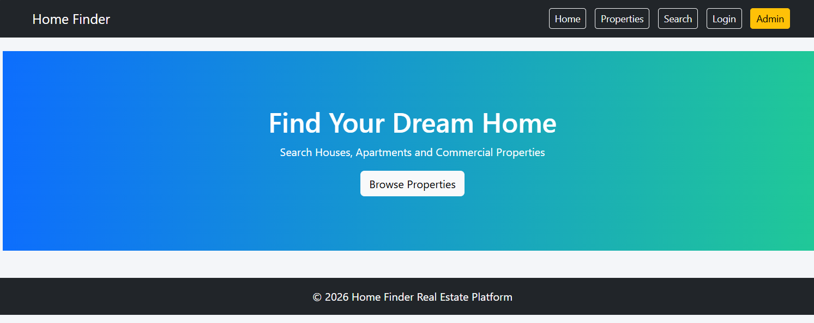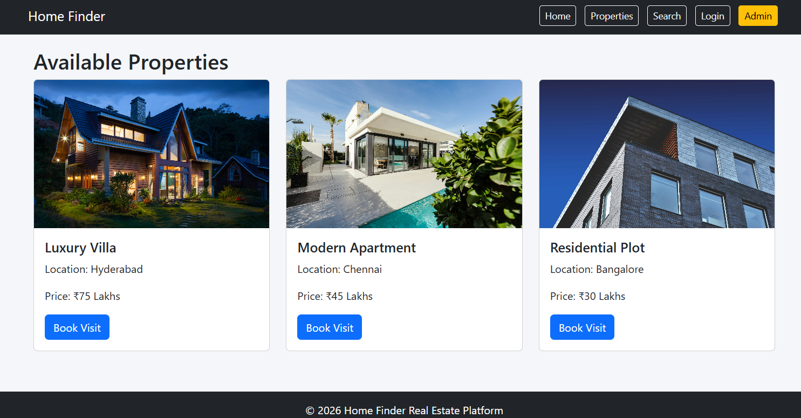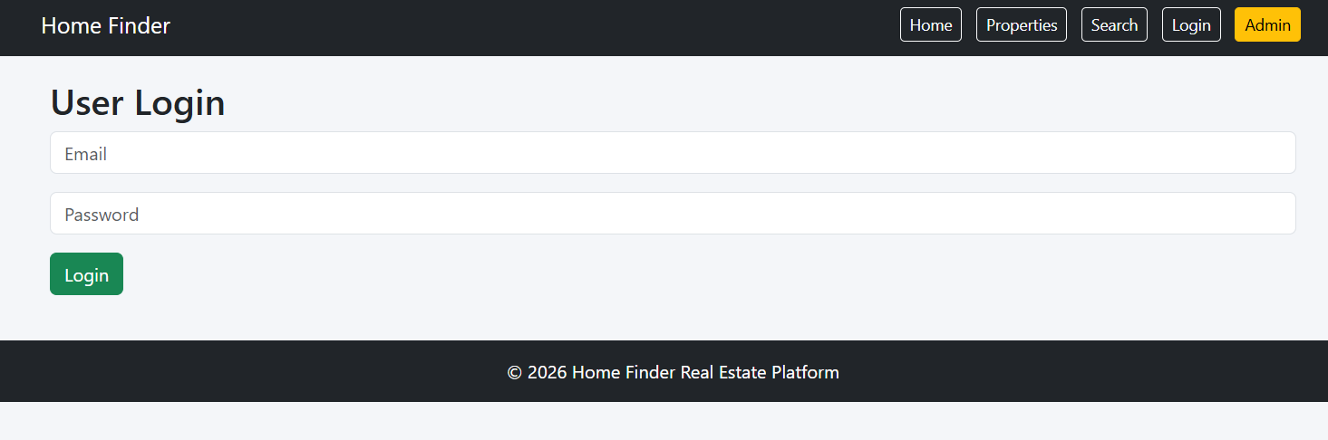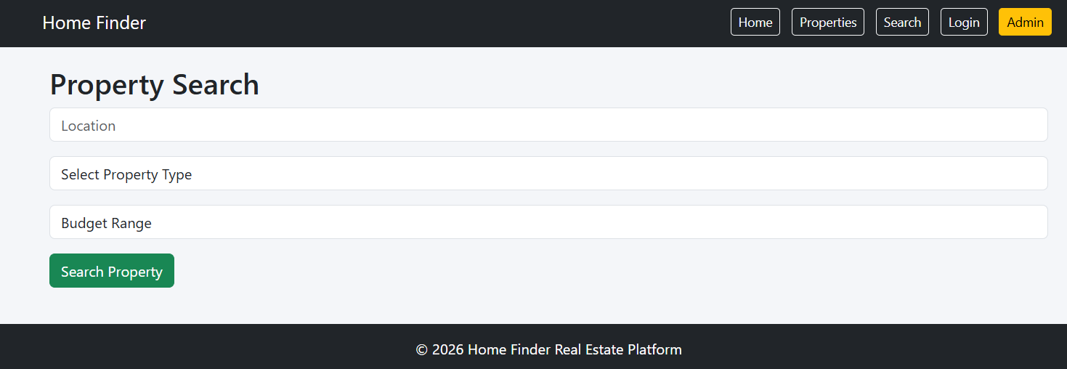

EXPERIMENT-12:
Aim: To develop an online insurance management system that allows users to compare policies, purchase insurance, manage premiums, receive renewal alerts, and file claims through a secure web platform.
Code:
<!DOCTYPE html>
<html lang="en">
<head>
<meta charset="UTF-8">
<meta name="viewport" content="width=device-width, initial-scale=1.0">
<title>InsureEasy - Insurance Management System</title>

<link href="https://cdn.jsdelivr.net/npm/bootstrap@5.3.3/dist/css/bootstrap.min.css" rel="stylesheet">

<style>
body{
background:#f5f7fa;
font-family:Arial,sans-serif;
}
.hero{
background:linear-gradient(to right,#007bff,#00b894);
color:white;
text-align:center;
padding:80px 20px;
}
.section{
display:none;
padding:20px;
}
.active{
display:block;
}
.card{
margin-bottom:20px;
}
.footer{
background:#212529;
color:white;
text-align:center;
padding:15px;
margin-top:20px;
}
</style>
</head>

<body>

<nav class="navbar navbar-expand-lg navbar-dark bg-dark">
<div class="container">
<a class="navbar-brand" href="#">InsureEasy</a>

<div>
<button class="btn btn-outline-light btn-sm m-1" onclick="showSection('home')">Home</button>
<button class="btn btn-outline-light btn-sm m-1" onclick="showSection('policies')">Policies</button>
<button class="btn btn-outline-light btn-sm m-1" onclick="showSection('agent')">Agent</button>
<button class="btn btn-outline-light btn-sm m-1" onclick="showSection('user')">User</button>
<button class="btn btn-warning btn-sm m-1" onclick="showSection('admin')">Admin</button>
</div>
</div>
</nav>

<!-- Home -->
<div id="home" class="section active">
<div class="hero">
<h1>InsureEasy Insurance Platform</h1>
<p>Compare, Purchase and Manage Insurance Policies Online</p>
</div>
</div>

<!-- Policies -->
<div id="policies" class="section container">
<h2>Available Insurance Policies</h2>

<div class="row">

<div class="col-md-4">
<div class="card p-3">
<h4>Health Insurance</h4>
<p>Coverage up to ₹10 Lakhs</p>
<button class="btn btn-primary">View Details</button>
</div>
</div>

<div class="col-md-4">
<div class="card p-3">
<h4>Auto Insurance</h4>
<p>Comprehensive Vehicle Protection</p>
<button class="btn btn-primary">View Details</button>
</div>
</div>

<div class="col-md-4">
<div class="card p-3">
<h4>Home Insurance</h4>
<p>Protect Your Property</p>
<button class="btn btn-primary">View Details</button>
</div>
</div>

</div>
</div>

<!-- Agent -->
<div id="agent" class="section container">
<h2>Agent Dashboard</h2>

<input type="text" class="form-control mb-2" placeholder="Customer Name">
<input type="text" class="form-control mb-2" placeholder="Policy Name">

<button class="btn btn-success mb-3">
Create Customer Policy
</button>

<ul class="list-group">
<li class="list-group-item">Manage Customer Details</li>
<li class="list-group-item">Manage Policy Details</li>
<li class="list-group-item">Send SMS Alerts</li>
</ul>

</div>

<!-- User -->
<div id="user" class="section container">
<h2>User Portal</h2>

<input type="email" class="form-control mb-2" placeholder="Email">
<input type="password" class="form-control mb-2" placeholder="Password">

<button class="btn btn-primary mb-3">Login</button>

<table class="table table-bordered">
<tr>
<th>Policy</th>
<th>Status</th>
<th>Renewal Date</th>
</tr>

<tr>
<td>Health Insurance</td>
<td>Active</td>
<td>20-12-2026</td>
</tr>

</table>

</div>

<!-- Admin -->
<div id="admin" class="section container">

<h2>Admin Dashboard</h2>

<div class="card p-3">
<ul>
<li>Admin Login</li>
<li>Approve Agent Login</li>
<li>View All Agent Details</li>
<li>Manage Policies</li>
<li>Manage Customers</li>
<li>Generate Reports</li>
</ul>
</div>

</div>

<div class="footer">
© 2026 InsureEasy Insurance Management System
</div>

<script>
function showSection(id)
{
document.querySelectorAll('.section')
.forEach(section =>
section.classList.remove('active'));

document.getElementById(id)
.classList.add('active');
}
</script>

</body>
</html>
Output:
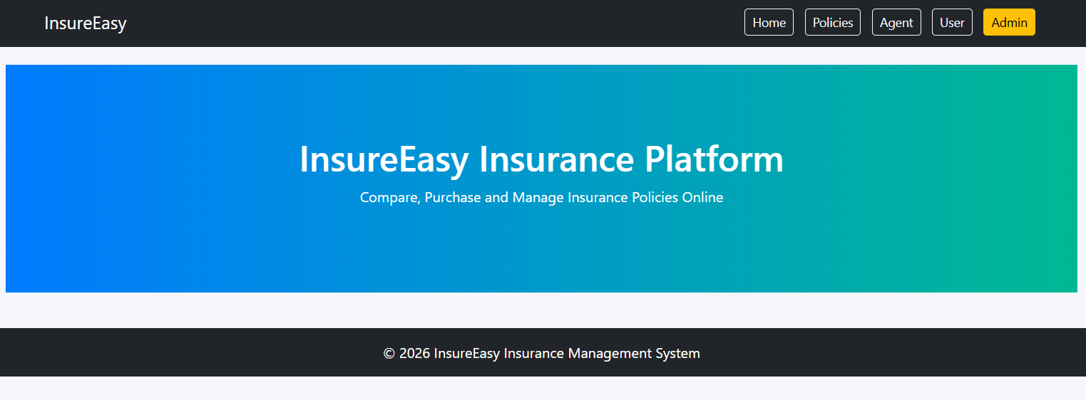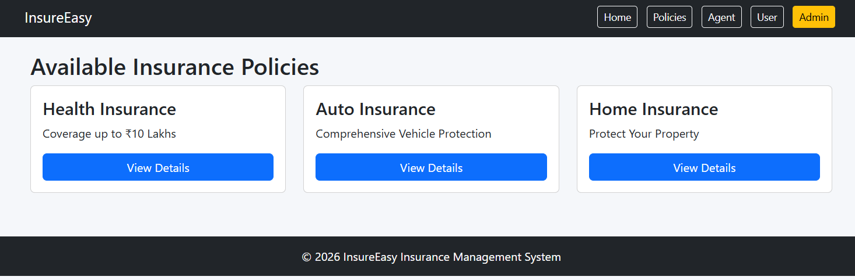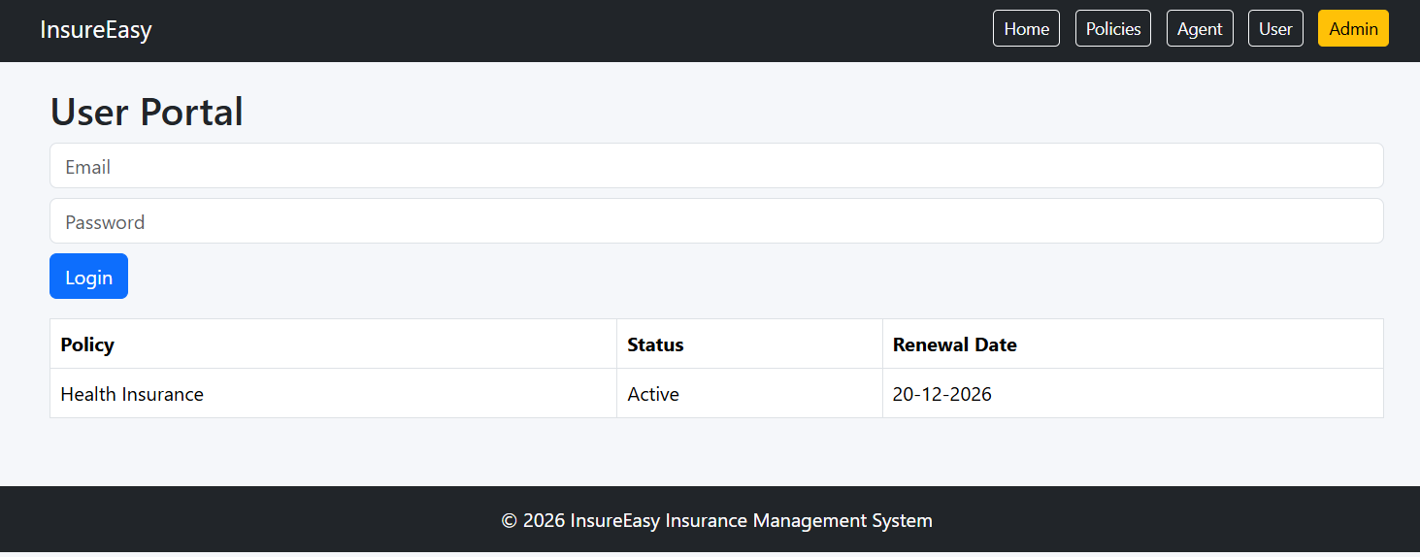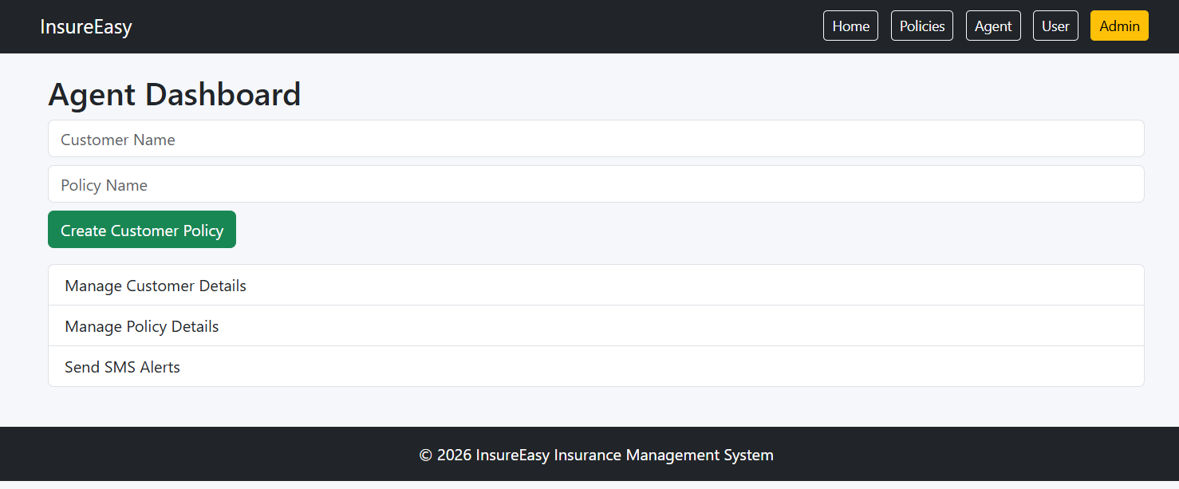

Experiment-13:
Aim: To develop an online Flowers and Gifts Shopping System that allows customers to browse products, place orders, schedule deliveries, make secure payments, and track orders through a user-friendly web application.
Code:
<!DOCTYPE html>
<html lang="en">
<head>
<meta charset="UTF-8">
<meta name="viewport" content="width=device-width, initial-scale=1.0">
<title>BlossomGifts - Flowers & Gifts Store</title>

<link href="https://cdn.jsdelivr.net/npm/bootstrap@5.3.3/dist/css/bootstrap.min.css" rel="stylesheet">

<style>
body{
font-family:Arial,sans-serif;
background:#f8f9fa;
}
.hero{
background:linear-gradient(to right,#ff69b4,#ff1493);
color:white;
text-align:center;
padding:80px 20px;
}
.section{
display:none;
padding:20px;
}
.active{
display:block;
}
.card{
margin-bottom:20px;
}
.card img{
height:220px;
object-fit:cover;
}
.footer{
background:#212529;
color:white;
text-align:center;
padding:15px;
margin-top:20px;
}
</style>
</head>

<body>

<nav class="navbar navbar-expand-lg navbar-dark bg-dark">
<div class="container">
<a class="navbar-brand" href="#">BlossomGifts</a>

<div>
<button class="btn btn-outline-light btn-sm m-1" onclick="showSection('home')">Home</button>
<button class="btn btn-outline-light btn-sm m-1" onclick="showSection('products')">Products</button>
<button class="btn btn-outline-light btn-sm m-1" onclick="showSection('cart')">Cart</button>
<button class="btn btn-outline-light btn-sm m-1" onclick="showSection('orders')">Orders</button>
<button class="btn btn-outline-light btn-sm m-1" onclick="showSection('login')">Login</button>
<button class="btn btn-warning btn-sm m-1" onclick="showSection('admin')">Admin</button>
</div>
</div>
</nav>

<!-- Home -->
<div id="home" class="section active">
<div class="hero">
<h1>BlossomGifts</h1>
<p>Send Flowers & Gifts for Every Occasion</p>
<button class="btn btn-light" onclick="showSection('products')">
Shop Now
</button>
</div>
</div>

<!-- Products -->
<div id="products" class="section container">

<h2>Flowers & Gifts</h2>

<div class="row">

<div class="col-md-4">
<div class="card">
<img src="https://images.unsplash.com/photo-1526045612212-70caf35c14df" class="card-img-top">
<div class="card-body">
<h5>Rose Bouquet</h5>
<p>₹799</p>
<button class="btn btn-primary" onclick="addToCart('Rose Bouquet')">
Add to Cart
</button>
</div>
</div>
</div>

<div class="col-md-4">
<div class="card">
<img src="https://images.unsplash.com/photo-1515934751635-c81c6bc9a2d8" class="card-img-top">
<div class="card-body">
<h5>Birthday Gift Box</h5>
<p>₹1499</p>
<button class="btn btn-primary" onclick="addToCart('Birthday Gift Box')">
Add to Cart
</button>
</div>
</div>
</div>

<div class="col-md-4">
<div class="card">
<img src="https://images.unsplash.com/photo-1513475382585-d06e58bcb0e0" class="card-img-top">
<div class="card-body">
<h5>Teddy Bear Gift</h5>
<p>₹999</p>
<button class="btn btn-primary" onclick="addToCart('Teddy Bear Gift')">
Add to Cart
</button>
</div>
</div>
</div>

</div>
</div>

<!-- Cart -->
<div id="cart" class="section container">
<h2>Shopping Cart</h2>
<ul id="cartItems" class="list-group"></ul>
</div>

<!-- Orders -->
<div id="orders" class="section container">
<h2>Order History</h2>

<table class="table table-bordered">
<tr>
<th>Order ID</th>
<th>Product</th>
<th>Status</th>
</tr>

<tr>
<td>1001</td>
<td>Rose Bouquet</td>
<td>Delivered</td>
</tr>

<tr>
<td>1002</td>
<td>Birthday Gift Box</td>
<td>Shipped</td>
</tr>

</table>
</div>

<!-- Login -->
<div id="login" class="section container">
<h2>Customer Login</h2>

<input type="email" class="form-control mb-3" placeholder="Email">
<input type="password" class="form-control mb-3" placeholder="Password">

<button class="btn btn-success">
Login
</button>
</div>

<!-- Admin -->
<div id="admin" class="section container">

<h2>Admin Dashboard</h2>

<div class="card p-3">
<ul>
<li>Manage Products</li>
<li>Add New Gifts & Flowers</li>
<li>Update Product Price</li>
<li>Manage Orders</li>
<li>Manage Customers</li>
<li>Inventory Management</li>
<li>Order Reports</li>
</ul>
</div>

</div>

<div class="footer">
© 2026 BlossomGifts Online Flowers & Gifts Store
</div>

<script>

function showSection(id)
{
document.querySelectorAll('.section')
.forEach(section =>
section.classList.remove('active'));

document.getElementById(id)
.classList.add('active');
}

function addToCart(product)
{
let item=document.createElement("li");
item.className="list-group-item";
item.innerText=product;

document.getElementById("cartItems")
.appendChild(item);

alert(product + " added to cart!");
}

</script>

</body>
</html>
Output:
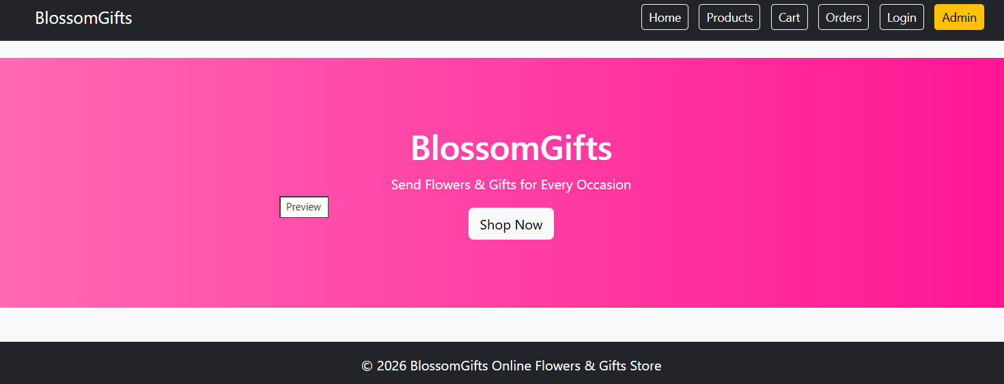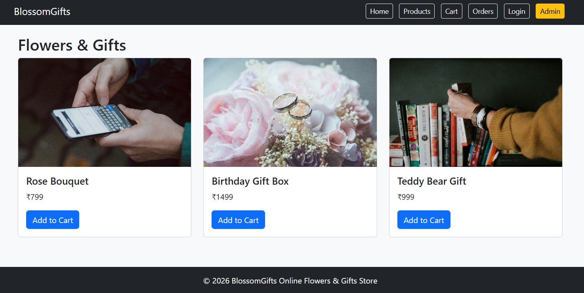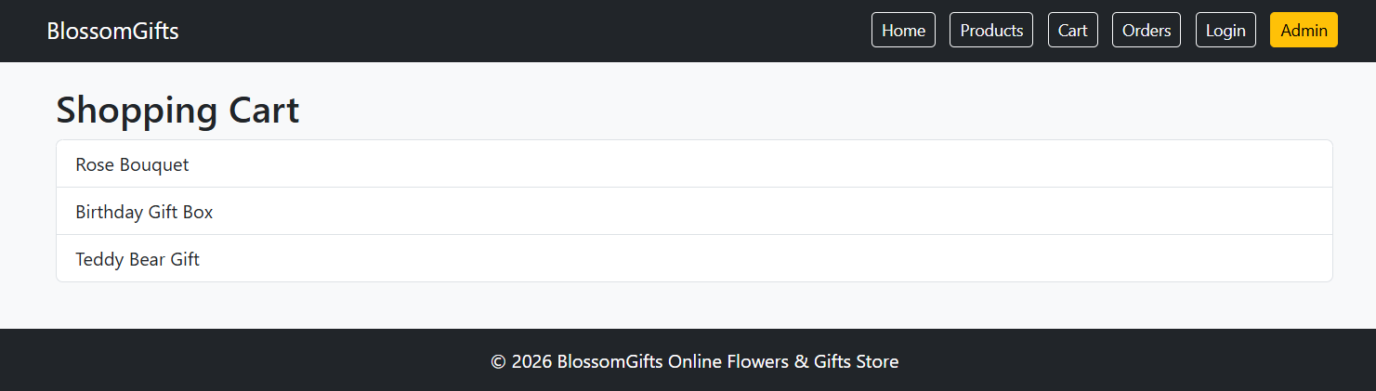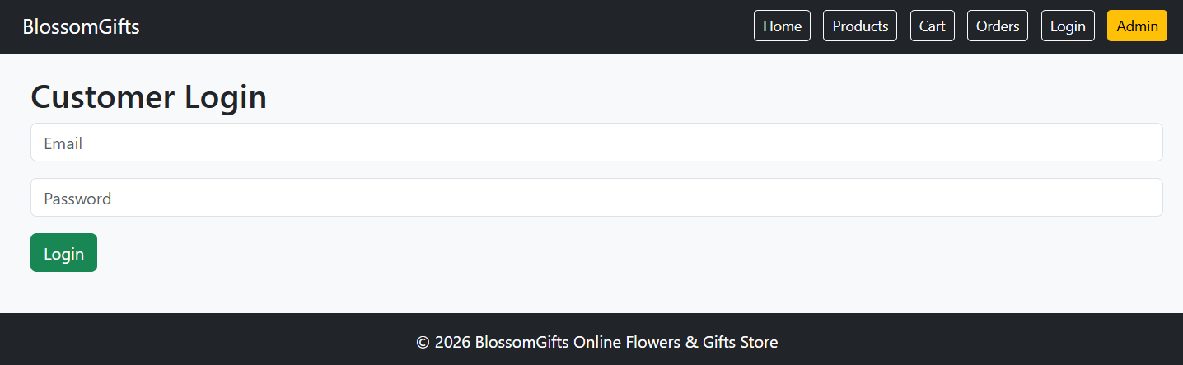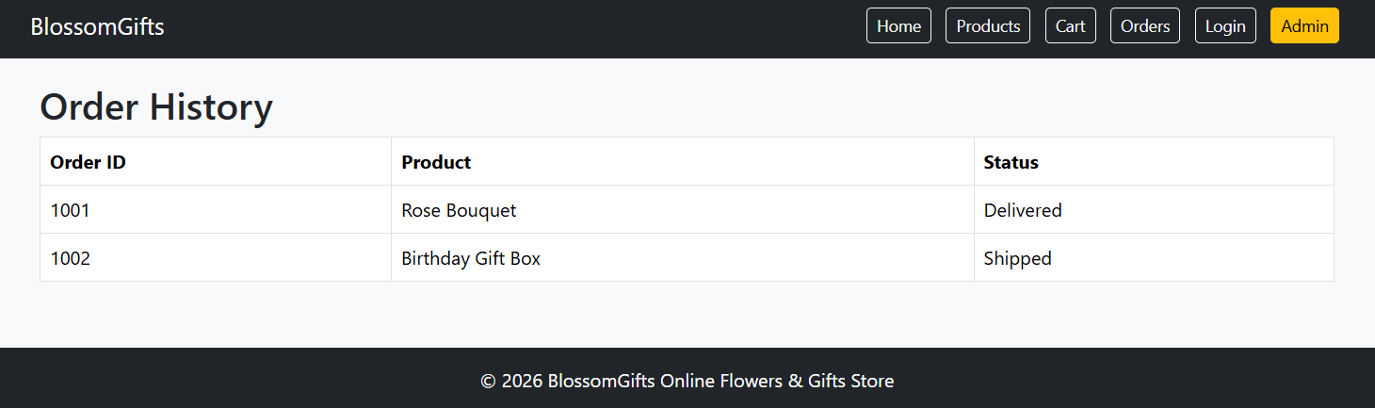

Experiment-14:
Aim: To develop an online marketplace for buying and selling second-hand products, enabling users to create listings, search items, manage transactions, and securely connect buyers with sellers.
Code:
<!DOCTYPE html>
<html lang="en">
<head>
<meta charset="UTF-8">
<meta name="viewport" content="width=device-width, initial-scale=1.0">
<title>ReNewMarket - Second Hand Marketplace</title>

<link href="https://cdn.jsdelivr.net/npm/bootstrap@5.3.3/dist/css/bootstrap.min.css" rel="stylesheet">

<style>
body{
font-family: Arial, sans-serif;
background:#f4f6f9;
}
.hero{
background:linear-gradient(to right,#28a745,#20c997);
color:white;
text-align:center;
padding:80px 20px;
}
.section{
display:none;
padding:20px;
}
.active{
display:block;
}
.card{
margin-bottom:20px;
}
.card img{
height:220px;
object-fit:cover;
}
.footer{
background:#212529;
color:white;
text-align:center;
padding:15px;
margin-top:20px;
}
</style>
</head>

<body>

<!-- Navbar -->
<nav class="navbar navbar-expand-lg navbar-dark bg-dark">
<div class="container">
<a class="navbar-brand" href="#">ReNewMarket</a>

<div>
<button class="btn btn-outline-light btn-sm m-1" onclick="showSection('home')">Home</button>
<button class="btn btn-outline-light btn-sm m-1" onclick="showSection('products')">Products</button>
<button class="btn btn-outline-light btn-sm m-1" onclick="showSection('sell')">Sell Item</button>
<button class="btn btn-outline-light btn-sm m-1" onclick="showSection('login')">Login</button>
<button class="btn btn-warning btn-sm m-1" onclick="showSection('admin')">Admin</button>
</div>
</div>
</nav>

<!-- Home -->
<div id="home" class="section active">
<div class="hero">
<h1>ReNewMarket</h1>
<p>Buy and Sell Pre-Owned Products Easily</p>
<button class="btn btn-light" onclick="showSection('products')">
Browse Products
</button>
</div>
</div>

<!-- Products -->
<div id="products" class="section container">

<h2>Available Products</h2>

<div class="row">

<div class="col-md-4">
<div class="card">
<img src="https://images.unsplash.com/photo-1511707171634-5f897ff02aa9" class="card-img-top">
<div class="card-body">
<h5>Used Smartphone</h5>
<p>Price: ₹8,000</p>
<button class="btn btn-primary">Buy Now</button>
</div>
</div>
</div>

<div class="col-md-4">
<div class="card">
<img src="https://images.unsplash.com/photo-1505740420928-5e560c06d30e" class="card-img-top">
<div class="card-body">
<h5>Headphones</h5>
<p>Price: ₹1,500</p>
<button class="btn btn-primary">Buy Now</button>
</div>
</div>
</div>

<div class="col-md-4">
<div class="card">
<img src="https://images.unsplash.com/photo-1549187774-b4e9b0445b41" class="card-img-top">
<div class="card-body">
<h5>Office Chair</h5>
<p>Price: ₹3,500</p>
<button class="btn btn-primary">Buy Now</button>
</div>
</div>
</div>

</div>
</div>

<!-- Sell Item -->
<div id="sell" class="section container">

<h2>Sell Your Product</h2>

<input type="text" class="form-control mb-3" placeholder="Product Name">

<input type="number" class="form-control mb-3" placeholder="Price">

<textarea class="form-control mb-3" placeholder="Description"></textarea>

<button class="btn btn-success"
onclick="alert('Product Listed Successfully!')">
Submit Listing
</button>

</div>

<!-- Login -->
<div id="login" class="section container">

<h2>User Login</h2>

<input type="email" class="form-control mb-3" placeholder="Email">

<input type="password" class="form-control mb-3" placeholder="Password">

<button class="btn btn-primary">
Login
</button>

</div>

<!-- Admin -->
<div id="admin" class="section container">

<h2>Admin Dashboard</h2>

<div class="card p-3">
<ul>
<li>User Management</li>
<li>Add/Edit/Delete Categories</li>
<li>Edit/Delete Products</li>
<li>Manage Orders</li>
<li>Update Logistics Status</li>
<li>View Marketplace Statistics</li>
</ul>
</div>

</div>

<div class="footer">
© 2026 ReNewMarket Marketplace
</div>

<script>

function showSection(id)
{
document.querySelectorAll('.section')
.forEach(section =>
section.classList.remove('active'));

document.getElementById(id)
.classList.add('active');
}

</script>

</body>
</html>
Output:
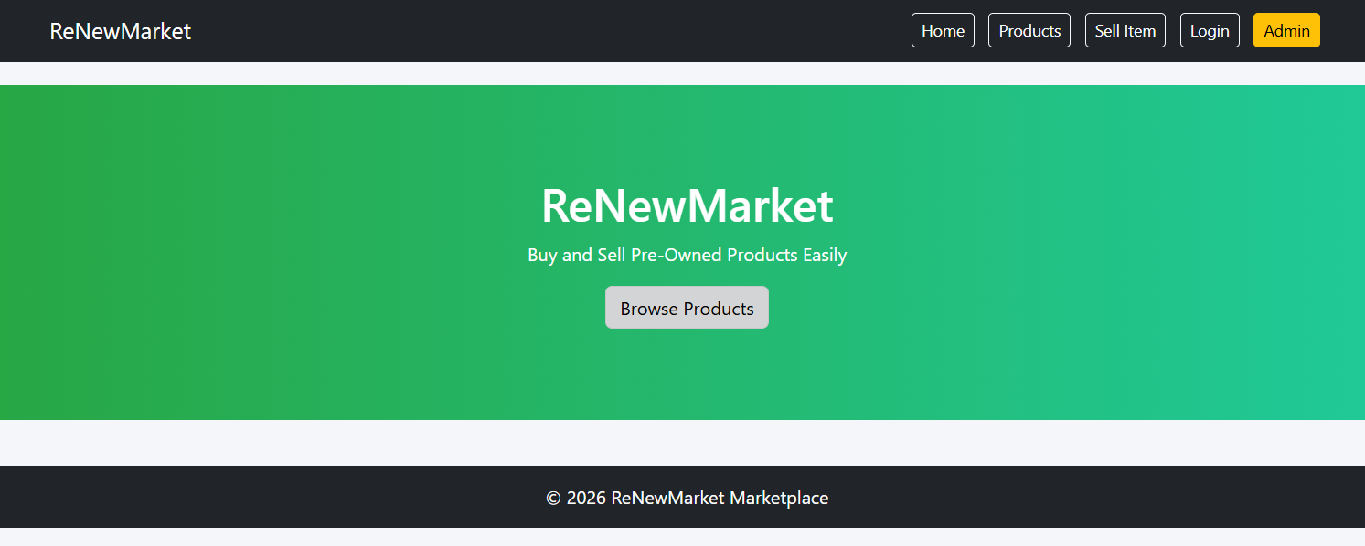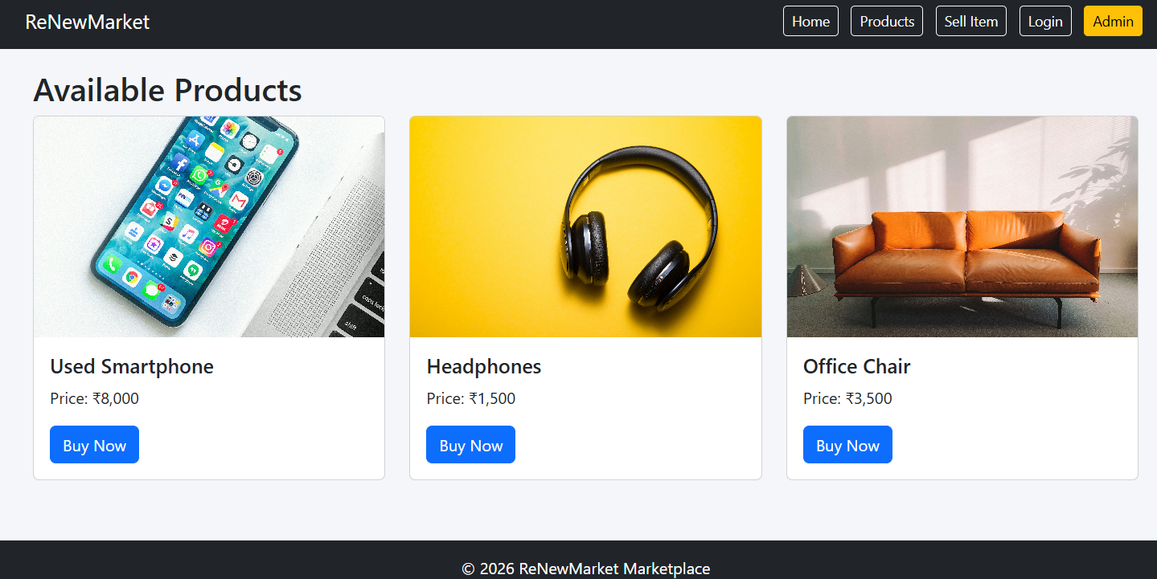
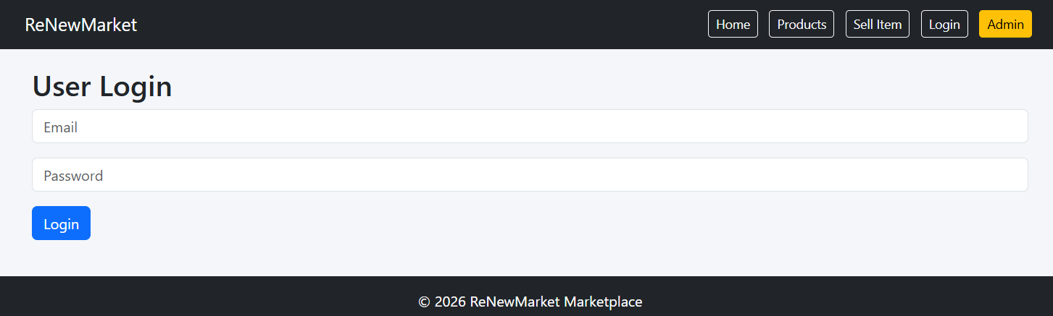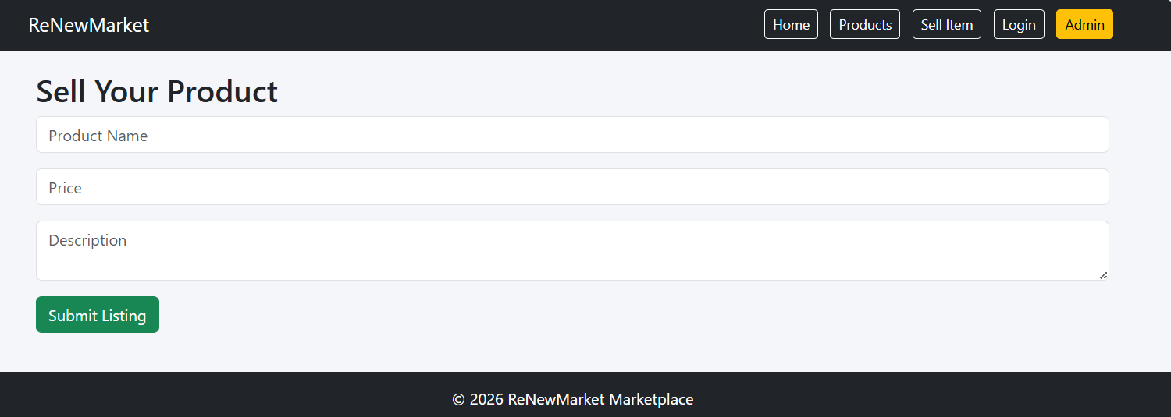

Experiment-15:
Aim: To develop an online Toll Payment System that enables users to purchase toll passes, make advance toll payments, generate QR codes, manage e-wallets, and verify toll transactions efficiently, reducing waiting time at toll plazas.
Code:
<!DOCTYPE html>
<html lang="en">
<head>
<meta charset="UTF-8">
<meta name="viewport" content="width=device-width, initial-scale=1.0">
<title>EasyToll - Online Toll Payment System</title>

<link href="https://cdn.jsdelivr.net/npm/bootstrap@5.3.3/dist/css/bootstrap.min.css" rel="stylesheet">

<style>
body{
font-family: Arial, sans-serif;
background:#f4f6f9;
}
.hero{
background:linear-gradient(to right,#ff9800,#ff5722);
color:white;
text-align:center;
padding:80px 20px;
}
.section{
display:none;
padding:20px;
}
.active{
display:block;
}
.card{
margin-bottom:20px;
}
.footer{
background:#212529;
color:white;
text-align:center;
padding:15px;
margin-top:20px;
}
</style>
</head>
<body>

<!-- Navigation -->
<nav class="navbar navbar-expand-lg navbar-dark bg-dark">
<div class="container">
<a class="navbar-brand" href="#">EasyToll</a>

<div>
<button class="btn btn-outline-light btn-sm m-1" onclick="showSection('home')">Home</button>
<button class="btn btn-outline-light btn-sm m-1" onclick="showSection('wallet')">eWallet</button>
<button class="btn btn-outline-light btn-sm m-1" onclick="showSection('pass')">Toll Pass</button>
<button class="btn btn-outline-light btn-sm m-1" onclick="showSection('login')">Login</button>
<button class="btn btn-warning btn-sm m-1" onclick="showSection('admin')">Admin</button>
</div>

</div>
</nav>

<!-- Home -->
<div id="home" class="section active">
<div class="hero">
<h1>EasyToll System</h1>
<p>Pay Tolls Online and Skip the Queue</p>

<button class="btn btn-light"
onclick="showSection('pass')">
Apply Toll Pass
</button>

</div>
</div>

<!-- Wallet -->
<div id="wallet" class="section container">

<h2>eWallet</h2>

<input type="number"
class="form-control mb-3"
placeholder="Enter Amount">

<button class="btn btn-success"
onclick="alert('Money Added Successfully!')">
Add Money
</button>

</div>

<!-- Toll Pass -->
<div id="pass" class="section container">

<h2>Apply New Toll Pass</h2>

<input type="text"
class="form-control mb-3"
placeholder="Vehicle Number">

<select class="form-control mb-3">
<option>Select Vehicle Type</option>
<option>Car</option>
<option>Bike</option>
<option>Bus</option>
<option>Truck</option>
</select>

<button class="btn btn-primary"
onclick="generateQR()">
Generate QR Pass
</button>

<br><br>

<div id="qrResult" class="alert alert-success" style="display:none;">
QR Code Generated Successfully!<br>
Pass ID: ET2026001
</div>

</div>

<!-- Login -->
<div id="login" class="section container">

<h2>User Login</h2>

<input type="email"
class="form-control mb-3"
placeholder="Email">

<input type="password"
class="form-control mb-3"
placeholder="Password">

<button class="btn btn-success">
Login
</button>

</div>

<!-- Admin -->
<div id="admin" class="section container">

<h2>Admin Dashboard</h2>

<div class="card p-3">

<ul>
<li>Manage Users</li>
<li>Manage Toll Passes</li>
<li>Approve Toll Pass</li>
<li>Generate QR Codes</li>
<li>Create Toll Details</li>
<li>View Transactions</li>
<li>Manage Toll Gates</li>
</ul>

</div>

</div>

<!-- Toll Gate User -->
<div class="container mt-4">
<div class="card p-3">

<h3>Toll Gate Verification</h3>

<input type="text"
class="form-control mb-2"
placeholder="Enter Pass ID">

<button class="btn btn-warning"
onclick="alert('Toll Pass Verified Successfully!')">
Verify Pass
</button>

</div>
</div>

<div class="footer">
© 2026 EasyToll Online Toll Payment System
</div>

<script>

function showSection(id)
{
document.querySelectorAll('.section')
.forEach(section =>
section.classList.remove('active'));

document.getElementById(id)
.classList.add('active');
}

function generateQR()
{
document.getElementById("qrResult").style.display="block";
}

</script>

</body>
</html>

Output:
